# **How do I OCR a PDF using Google Drive?**

All students, staff and faculty members with access Google account will be able to OCR a PDF file through Google Drive. OCR is performed on a PDF when converting a document from PDF to a .docx file.  
  
**Please note**: This is not considered a final solution; additional handling may be required after the OCR.   **Optical Character Recognition (OCR):**

Google provides an ability to perform Optical Character Recognition (OCR) for PDFs which have been scanned.  This significantly improves the accessibility of the document, but it is not considered a final solution, and more handling may be required.

1. In the upper right hand of your Google account, click the icon for your apps.

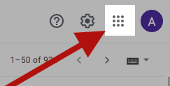

2. This will open up a new menu. Select Google Drive.

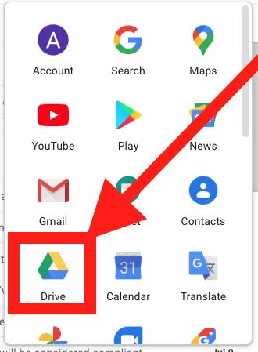

3. You will now be in your Google Drive folder.

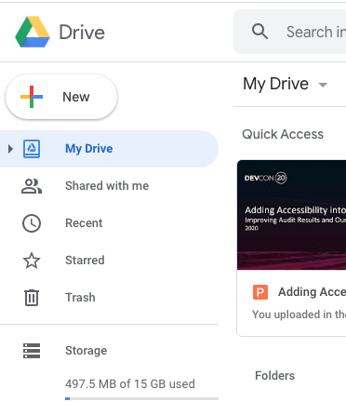

4. Click on the **New** button.



5. The file uploader appears. Click on **File upload.**

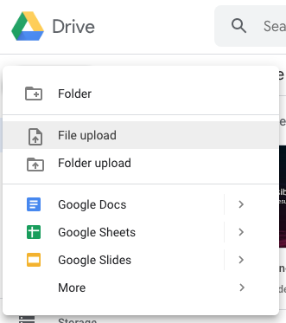

6. A new dialogue window enables file selection**.**

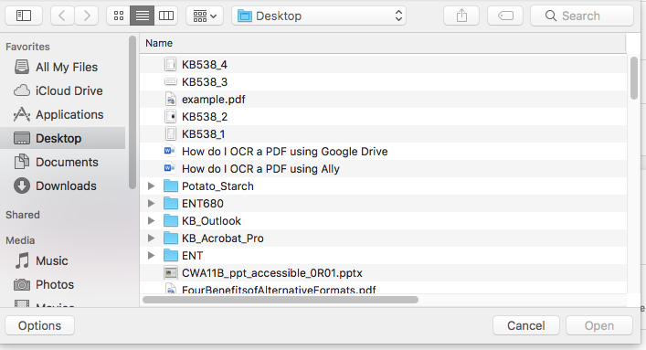

7. Select the file to upload. When selected, the file will be highlighted and the **Open** button becomes available**.** Click on the **Open** Button.

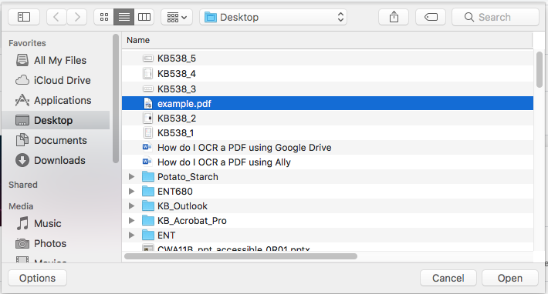

8. When the upload is complete, a notification appears**.**

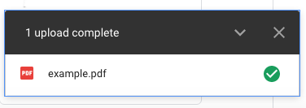

9. Now the file is availablein Google Drive. Notice that the PDF has been scanned incorrectly, and that the text is on its side, instead of upright. This causes a significant problem for assistive technology.

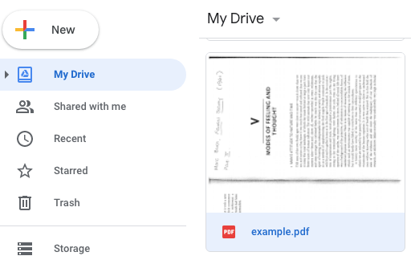

10. Right-click on the file. A new menu will appear. Select **Open With** >

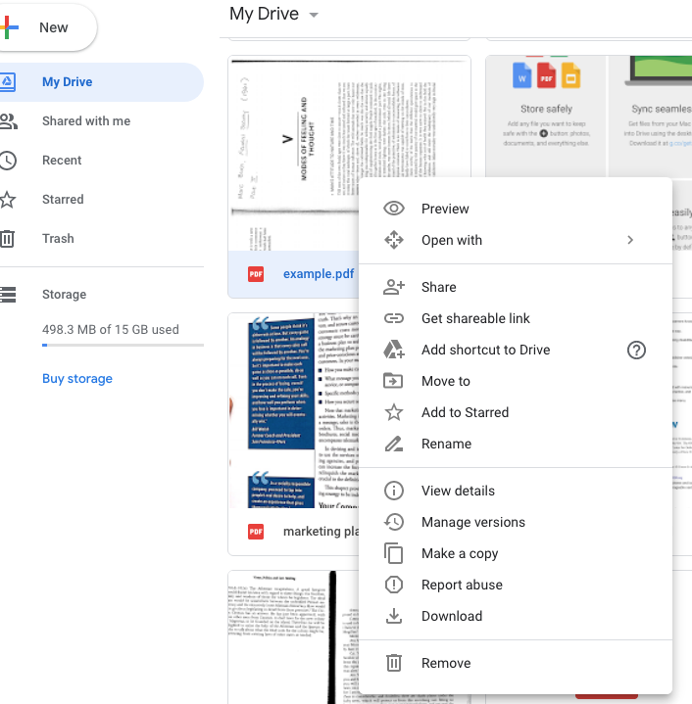

11. Select **Open With** > Google Docs.

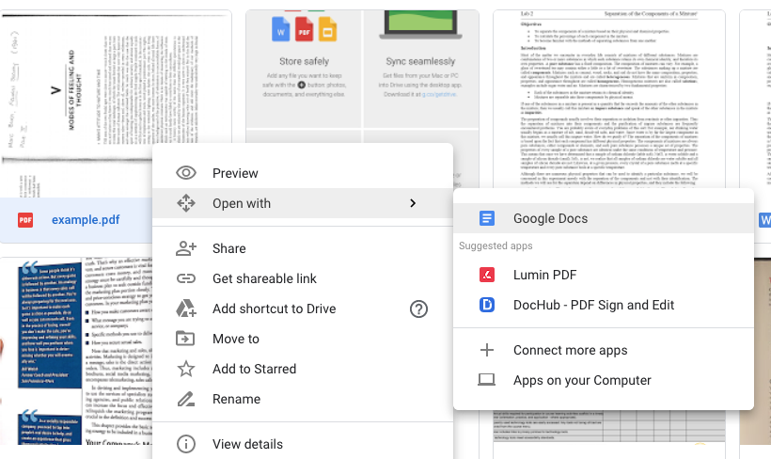

12. The following spinner will appear. Google is OCRing the document as it converts it to a docx.



13. The document has been OCRed and converted to a docx. Notice that the text that was formerly on its side is now upright, and readable by assistive technology. The document is much more accessible than it was before the conversion.

